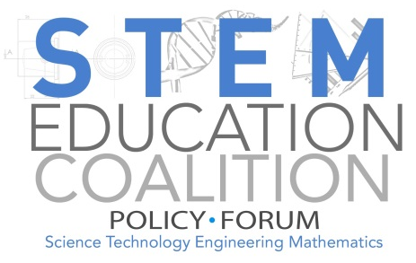

The Every Student Succeeds Act is now the law of the land! States have until April 3 or September 18, 2017 to submit their plans for compliance to the Department of Education (ED). As of February, nineteen states and the District of Columbia have released, submitted, or published at least a draft of their ESSA plans. Below is an overview of which plans have included an emphasis on STEM, afterschool, and/or both.

Overview of State Plans:
- Half of the published plans have proposed an integrated focus on informal, afterschool, or out-of-school learning as a strategy for student success.
- Another half of the plans have some focus on STEM. However, not many of the plans use the term “STEM”.
  - States using Next Generation Science Standards are, to varying degrees, embracing integrated STEM learning.
  - Many states are also explicitly addressing engineering in addition to math and science, but not necessarily technology.
  - We only stated that a state has placed an emphasis on STEM if they discussed STEM in their plan beyond what’s required by ESSA
- Seven of the nineteen plans include some mention of STEM and/or afterschool in their plan for Title IV, Part A, Student Support and Academic Enrichment Grants.
- Colorado, Iowa, North Dakota, Oregon, and Tennessee include STEM and afterschool while also mentioning these areas in their Title IV, Part A proposal.

State and Submission Date | STEM | Afterschool | Title IV.A
Arizona (1/15/17)
Alaska (4/21/17) |  | X
Arkansas
Colorado (2/10/17) | X | X | X
Delaware (11/1/16)
District of Columbia (1/30/17) | X
Hawaii (12/28/16)
Idaho (11/2/16) |  |  | X
Iowa (1/6/17) | X | X | X
Illinois (11/18/16)
Kentucky (11/1/16)
Louisiana (9/28/16) |  | X
Maryland (12/5/16)
Michigan (2/14/17)
Montana (12/15/16) | X
North Carolina (9/30/16) | X
North Dakota (1/13/17) | X | X | X
Ohio (1/19/17)
Oklahoma ( 11/21/16) | X
Oregon (2/13/17) | X | X | X
Tennessee ( 12/19/16) | X | X | X
Washington ( 11/16/16) | X |  | X

